**Assignment 5**

**Simulate RPC (Create procedure on remote machine and call it from local machine)**

**List of programs for RPC**

**1. Find out the factorial of given number.**

**2. Implement Calculator (Basic operation).**

**3. Find out whether given number is Prime Number or not.**

**4. Print out the Fibonacci series till the given number.**

**5. Find the maximum value of an array of integers using RPC.**

**Server:**

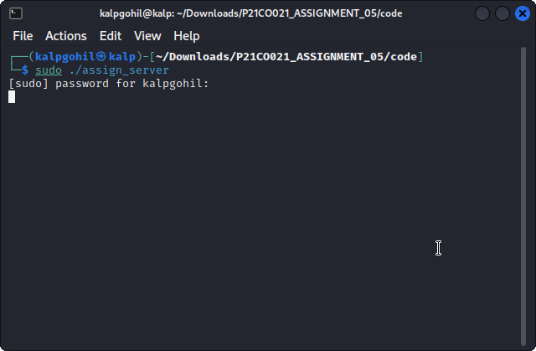

**Client:**

